Financial RAG Pipeline
System Architecture and Project Workflow
Version: 1.0
Project Type: Retrieval-Augmented Generation (RAG) for Financial Documents
Purpose: Architecture Overview, Workflow Design, and Experiment Framework

Executive Summary
The Financial RAG Pipeline is a modular Retrieval-Augmented Generation (RAG) system designed to answer questions from financial documents such as SEC filings, annual reports, earnings reports, and other corporate disclosures.
The system evaluates how different retrieval strategies impact answer quality by comparing:
- Fixed-size chunking versus semantic chunking
- Similarity-based retrieval versus retrieval with cross-encoder reranking
To ensure objective evaluation, the platform executes four experimental configurations and measures both retrieval effectiveness and answer quality using standard information retrieval metrics and RAGAS evaluation metrics.
The architecture separates ingestion, retrieval, generation, and evaluation into independent modules, making the system scalable, maintainable, and easy to extend.
This project evaluated a Financial RAG pipeline using four financial document types: SEC filings, earnings call transcripts, insurance claims, and loan documents. Two chunking strategies (Fixed and Semantic) were compared, with and without a BGE reranker.
The best chunking strategy depends heavily on the specific nature of your documents and the level of detail required by your RAG application.
Choosing the right strategy is a balancing act: small chunks offer high precision for retrieval, while large chunks provide the rich context necessary for the LLM to generate meaningful answers.
The following strategies are recommended based on document type and complexity:
Fixed-Size Chunking: Useful for quick prototyping or simple documents where speed is a priority. It is recommended to use a 10–20% overlap to ensure that facts split across boundaries aren't lost.
Semantic Chunking: Instead of relying on character counts, this technique uses embeddings to detect topic shifts. It is ideal for dense text where logical flow is more important than explicit paragraph markers.
Key Findings
Chunking Comparison
- Fixed Chunking produced 30 smaller chunks and achieved higher retrieval precision (86%) than Semantic Chunking (51%).
- Semantic Chunking generated only 12 larger chunks, which reduced retrieval precision but still contained sufficient information for accurate answers.
- Despite lower retrieval precision, Semantic Chunking delivered answer quality comparable to Fixed Chunking.
Reranking Impact
- Adding the BGE reranker consistently improved answer quality across both chunking methods.
- Reranking increased:
  - Mean Reciprocal Rank (MRR)
  - Faithfulness
  - Context Precision
- The highest Context Precision score (0.949) was achieved by Semantic Chunking + Reranking.
Performance Summary
Configuration | Strength
Fixed Chunking | Best retrieval precision
Fixed + Reranking | Best overall balance of accuracy and efficiency
Semantic Chunking | Better topic coherence for large documents
Semantic + Reranking | Highest context precision
Recommendation
For production deployment, Fixed Chunking (500 characters with 50 overlap) combined with BGE Reranking is recommended. This configuration delivered the highest faithfulness, strong retrieval performance, and the most predictable operational cost.
For long narrative documents such as SEC filings and earnings transcripts, Semantic Chunking with Reranking can be considered because it provides highly relevant context despite lower retrieval precision.
Limitations
The evaluation was conducted on a small dataset of only four documents. Because of the limited corpus size, Recall@5 reached 100% for all experiments and may not reflect real-world performance. Further validation on larger financial document collections is recommended before production implementation.

1. Project Objectives
The primary objectives of this project are:
Functional Objectives
- Ingest financial documents from multiple formats
- Generate embeddings and searchable vector indexes
- Retrieve relevant financial information efficiently
- Generate grounded answers using Large Language Models (LLMs)
- Provide source-backed responses
Research Objectives
- Evaluate the impact of chunking strategies
- Evaluate the impact of reranking techniques
- Identify the highest-performing retrieval architecture
- Measure answer quality and retrieval effectiveness

2. High-Level System Architecture
System Flow
Financial Documents
↓
Document Loading
↓
Metadata Normalization
↓
Chunk Generation
├── Fixed Chunking
└── Semantic Chunking
↓
Embedding Generation
↓
FAISS Vector Index Creation
├── Fixed Index
└── Semantic Index
↓
User Question
↓
Similarity Retrieval
↓
Optional Cross-Encoder Reranking
↓
Context Construction
↓
LLM Answer Generation
↓
Answer + Supporting Evidence
↓
Evaluation & Reporting

3. Architecture Layers
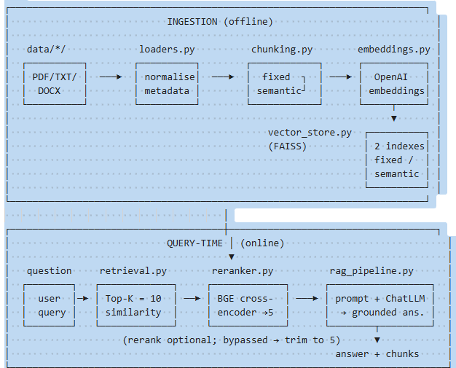
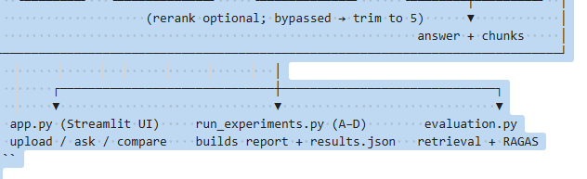
Layer 1: Data Ingestion
Purpose
Convert raw financial documents into standardized internal representations.
Inputs
- PDF Files
- TXT Files
- DOCX Files
Module
loaders.py
Responsibilities
- Read document contents
- Extract metadata
- Normalize file structures
- Create LangChain Document objects
Output
Standardized document objects containing:
- Content
- Source
- Page number
- Document type

Layer 2: Chunk Processing
Purpose
Transform large documents into retrievable chunks.
Module
chunking.py
Strategy A: Fixed Chunking
Uses:
RecursiveCharacterTextSplitter
Characteristics:
- Fixed chunk size
- Fixed overlap
- Simple implementation
- Baseline comparison
Advantages:
- Fast processing
- Predictable chunk sizes
Limitations:
- May split important context
- Ignores semantic boundaries

Strategy B: Semantic Chunking
Uses:
SemanticChunker
Characteristics:
- Context-aware splitting
- Preserves topic boundaries
- Produces meaningful retrieval units
Advantages:
- Better context preservation
- Improved retrieval relevance
Limitations:
- Higher processing cost
- More complex implementation

Layer 3: Embedding Generation
Purpose
Convert text chunks into vector representations.
Module
embeddings.py
Default Model
OpenAI text-embedding-3-large
Process
Text Chunk
↓
Embedding Model
↓
Dense Vector Representation
Output
Embeddings suitable for similarity search.

Layer 4: Vector Database Layer
Purpose
Store embeddings and enable efficient retrieval.
Module
vector_store.py
Technology
FAISS
Index Design
Two independent indexes are maintained:
Fixed Chunk Index
indexes/faiss_fixed
Semantic Chunk Index
indexes/faiss_semantic
Design Benefits
- Fair experimental comparison
- Independent retrieval testing
- Reduced configuration coupling

Layer 5: Retrieval Layer
Purpose
Find the most relevant document chunks for a query.
Module
retrieval.py
Workflow
User Question
↓
Question Embedding
↓
FAISS Similarity Search
↓
Top 10 Chunks
Output
RetrievedChunk objects containing:
- Chunk text
- Similarity score
- Metadata

Layer 6: Reranking Layer
Purpose
Improve retrieval precision before generation.
Module
reranker.py
Technology
BAAI/bge-reranker-large
Workflow
Top 10 Retrieved Chunks
↓
Cross-Encoder Scoring
↓
Rank by Relevance
↓
Top 5 Chunks
Expected Benefits
- Improved relevance
- Better context selection
- Reduced retrieval noise

Layer 7: Generation Layer
Purpose
Generate grounded answers from retrieved context.
Module
rag_pipeline.py
Workflow
Retrieved Context
↓
Prompt Construction
↓
ChatOpenAI
↓
Grounded Answer
Prompt Rules
The model must:
- Use only provided context
- Avoid hallucinations
- Return:
"Information not found in provided documents."
when evidence is unavailable.
Output
RAGResult
Containing:
- Question
- Generated Answer
- Retrieved Context
- Metadata

Layer 8: User Interface Layer
Technology
Streamlit
Module
app.py
Features
- Document upload
- Index creation
- Query interface
- Configuration controls
- Strategy comparison view

4. Query Execution Workflow
Runtime Process
Step 1:
User submits a question.
↓
Step 2:
System embeds the query.
↓
Step 3:
FAISS retrieves Top 10 similar chunks.
↓
Step 4:
Optional reranking selects the best 5 chunks.
↓
Step 5:
Context is formatted for the LLM.
↓
Step 6:
Prompt is submitted to GPT-4o-mini.
↓
Step 7:
Generated answer and supporting evidence are returned.

5. Experimental Framework
The architecture is designed around four controlled experiments.
Experiment Matrix
Experiment | Chunking Strategy | Reranking
A | Fixed | Disabled
B | Fixed | Enabled
C | Semantic | Disabled
D | Semantic | Enabled

Experimental Goals
Impact of Reranking
A → B
Measures reranking effectiveness on fixed chunks.
C → D
Measures reranking effectiveness on semantic chunks.

Impact of Chunking
A → C
Measures retrieval improvements from semantic chunking.
B → D
Measures combined improvements with reranking enabled.

6. Evaluation Framework
The project evaluates both retrieval quality and answer quality.

Retrieval Evaluation
Module
evaluation.py
Metrics
Precision@5
Measures the proportion of retrieved chunks that are relevant.
Recall@5
Measures how many relevant documents were retrieved.
Mean Reciprocal Rank (MRR)
Measures how quickly relevant documents appear in ranked results.
Benefits
- Deterministic
- Reproducible
- Low computational cost

Answer Quality Evaluation
Framework
RAGAS
Metrics
Faithfulness
Measures whether answers are supported by retrieved context.
Answer Relevancy
Measures whether answers address the user's question.
Context Precision
Measures relevance of supplied context.
Context Recall
Measures completeness of retrieved context.
Benefits
- End-to-end evaluation
- Measures actual user experience
- Captures retrieval-generation interactions

7. Key Architectural Decisions
Separate FAISS Indexes
Rationale:
- Prevents cross-contamination
- Enables direct comparisons
- Simplifies experimentation

Centralized Configuration
All parameters reside in config.py.
Benefits:
- Reproducibility
- Simplified tuning
- Easier deployment

Lazy Loading
Heavy dependencies load only when required.
Examples:
- SemanticChunker
- Cross Encoder
- RAGAS
Benefits:
- Faster startup
- Lower memory usage

Similarity Normalization
FAISS distances are converted into similarity scores:
Similarity = 1 / (1 + Distance)
Benefits:
- Easier interpretation
- Consistent UI presentation

Shared Data Contracts
Common data structures:
- RetrievedChunk
- RAGResult
Benefits:
- Loose coupling
- Easier maintenance
- Cleaner integrations

Resource Caching
Cached components include:
- Embedding models
- Reranking models
- Streamlit resources
Benefits:
- Reduced latency
- Improved scalability
- Better user experience

8. Technology Stack
Category | Technology
Framework | LangChain
Embeddings | OpenAI text-embedding-3-large
Vector Database | FAISS
Reranker | BAAI/bge-reranker-large
LLM | GPT-4o-mini
Evaluation | RAGAS
UI | Streamlit

9. Expected Deliverables
Technical Deliverables
- Financial document ingestion pipeline
- Fixed chunk retrieval index
- Semantic chunk retrieval index
- RAG question-answering engine
- Cross-encoder reranking module
- Evaluation framework

Reports
- results.json
- comparison_report.md

User Interface
Streamlit dashboard supporting:
- Document upload
- Index creation
- Query execution
- Configuration management
- Experiment comparison

10. Conclusion
The Financial RAG Pipeline serves as both a production-ready question-answering system and an experimental benchmarking platform.
By systematically comparing fixed versus semantic chunking and retrieval-only versus reranked retrieval, the project provides quantitative insights into how retrieval architecture influences answer quality for financial document analysis.
The modular design allows future enhancements such as hybrid search, alternative embedding models, vector databases, and advanced reranking strategies while maintaining a consistent evaluation framework.

